# S. Y. B. Tech (ECE)

**Trimester: VI Subject: Linux Based Python Laboratory (CET2005A)**

# Name: Class:

**Roll No.: Batch:**

# Experiment – 02 Title: Execution of Basic Linux Commands Performed on:

**Marks**

**Teacher’s Signature with date**

**Submitted on:**

**Aim**: To execute basic Linux commands

# Objective:

1. To know the basic Linux commands.
2. To execute the basic Linux command from Linux terminal.

# Theory:

The Linux command is a utility of the Linux operating system. All basic and advanced tasks can be done by executing commands. The commands are executed on the **Linux terminal**. The terminal is a command-line interface to interact with the system, which is similar to the command prompt in the Windows OS. *Commands in Linux are* **case-sensitive***.*

[**Linux**](https://www.javatpoint.com/linux-tutorial) provides a powerful command-line interface compared to other operating systems such as [**Windows**](https://www.javatpoint.com/windows) and **MacOS**. Some basic tasks such as creating a file, deleting a file, moving a file, and more can be easily implemented using basic Linux commands. In addition, some advanced tasks such as administrative tasks (including package installation, user management), networking tasks (ssh connection), security tasks, and many more can also be performed.

Linux terminal is a user-friendly terminal as it provides various support options. To open the Linux terminal, one has to press "**CTRL + ALT + T**" keys together, and execute a command by pressing the '**ENTER**' key.

The commonly used Linux commands are explained as below-

# man

Man stands for manual which is a reference book of a [Linux operating system](https://www.guru99.com/introduction-linux.html). It is similar to HELP file found in popular software. MAN command is used to get help on any command.

Syntax: man <Linux command>

Ex: man man, man mkdir etc.

1. **pwd**

**pwd** command is used to display the location of current working directory. Ex:

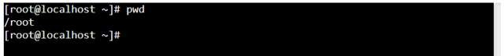

1. **mkdir Command**

The [**mkdir**](https://www.javatpoint.com/linux-mkdir) command is used to create a new directory under any directory.

**Syntax:**

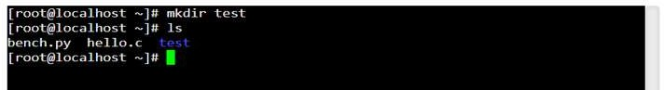mkdir **<directory** name**>** Ex:

1. **ls Command**

The [**ls**](https://www.javatpoint.com/linux-ls) command is used to display a list of content of a directory. It shows the files /directories in your current directory.

* + Directories are denoted in blue color.
  + Files are denoted in white.
  + You will find similar color schemes in different flavors of Linux.

**‘ls -R’ to shows all the files not only in directories but also subdirectories**

**‘ls -al’** gives detailed information of the files like the permissions, size, owner, etc. Ex:

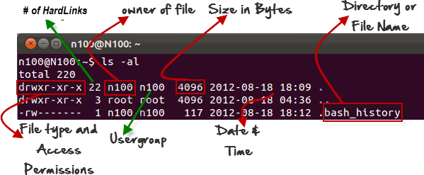

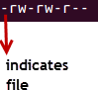The first ‘**–**’ implies that we have selected a file.

If it were a directory, **d** would have been shown.



The other characters are interpreted as-

|  |  |  |
| --- | --- | --- |
| **r** = | read | permission |
| **w** = | write | permission |
| **x** = | execute | permission |
| **–** = no permission |  |  |

Ex:

The first part of the code is **‘rw-**’ This suggests that the owner ‘Home’ can:

* + Read the file
  + Write or edit the file
  + 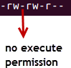He cannot execute the file since the execute bit is set to ‘-’.

The second part is **‘rw-’ .** It for the user group ‘Home’ and group-members can:

* + Read the file
  + Write or edit the file

The third part is for the world which means any user. It says **‘r -’.** This means the user can only:

* + Read the file

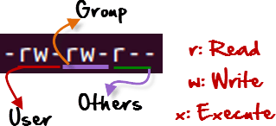

**Listing Hidden Files**

Hidden items in UNIX/Linux begin with a ‘.’ (period symbol) at the start of the file or directory. Any directory/file starting with a ‘.’ (period symbol) will not be seen unless you request for it. To view hidden files, use the command.

**ls -a**

ls has many other options as follows

* + - -l long list (displays lots of info)
    - -t sort by modification time
    - -S sort by size
    - -h list file sizes in human readable format
    - -r reverse the order Options can also be combined as: “ls -ltr”

1. **rmdir Command**

The [rmdir](https://www.javatpoint.com/linux-rmdir) command is used to delete a directory.

**Syntax:**

rmdir **<directory** name**>** Ex:

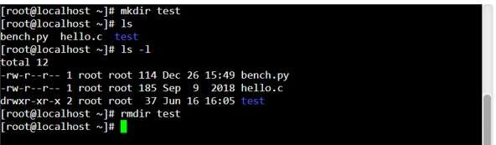

1. **cd Command**

The [cd](https://www.javatpoint.com/linux-cd) command is used to change the current directory.

**Syntax:**

cd **<directory** name**>**

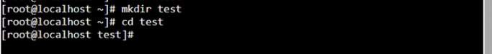

The cd .. command is used to switch to the parent directory.

The cd ~ command is used to jump to root directory from any current working directory. Ex.:

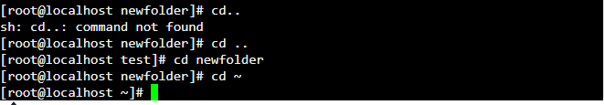

**Creating files in Linux:**

To create and edit a file in Linux requires an editor. The various editors that can be used with linux as follows-

* gedit
* nano/pico
* vi
* emacs

To create / Edit the file using “nano” or “vi” type “nano” followed by the filename on command prompt that opens the following editor.

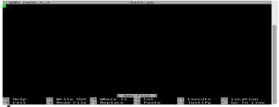

* + Edit the file (add content to the file)
  + To save the file use “ctrl+O” and press enter
  + To exit from the editor, press “ctrl+X”

**Displaying file contents:**

**cat command** is used to dump an entire file to standard output. It is good for displaying short, simple files.

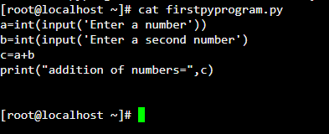Ex:

* head - displays the top part of a file, by default 10 lines
* tail - displays the bottom part of a file, by default 10 lines

**File Commands used to perform various operations on file are as follows:**

* To copy a file: cp
* To move or rename a file: mv
* To remove a file: rm
* To change file access permissions: chmod Examples:

1. 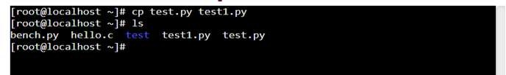cp command
2. mv command
   1. mv used to move the file

A new directory named ‘abc’ is created and moved the test from current directory to ‘abc’ directory. Changed directory to ‘abc’ and listed the content of directory that shows the moved file name.

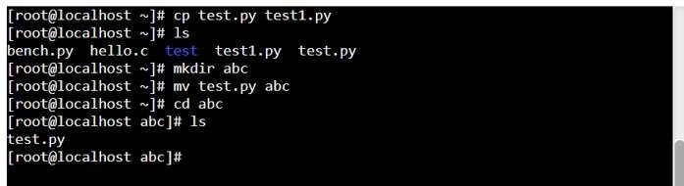

* 1. 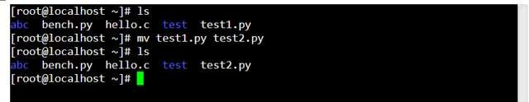mv can also be used to rename a file

1. rm command

To remove a file “recursively” the command used is rm –r. It is used to remove all files and directories. The deletions are permanent in Linux.

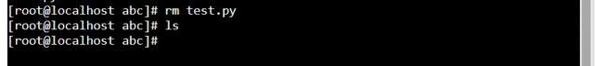

1. chmod command

one can change file permissions (read, write, execute) on a file/directory for the owner, group and the world using “chmod”.

Syntax:

chmod [**u**ser**/g**roup**/o**thers**/a**ll]+[permission] [file(s)]

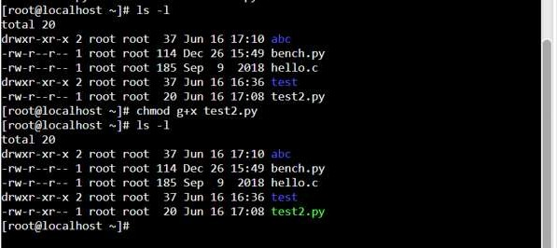

Steps to create a python file, execute a file, download/upload a file, view a file:

1. Create a python file



1. **Execute a python file**

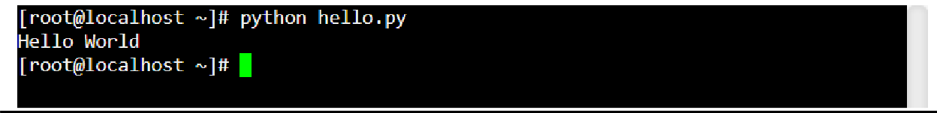

1. **Download a python file**



# Upload a file

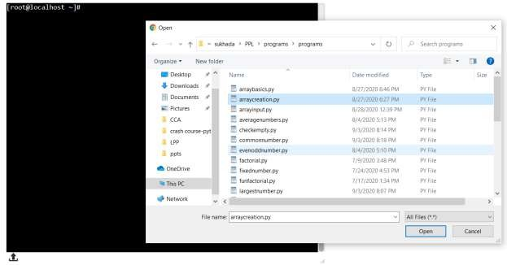

Click on this to upload file

1. Uploaded file can be viewed using ls command

**Input**:Linux Commands

**Output:** Output of each command

# Conclusion:

**Post Lab Questions:**

1. What are basic components of Linux?
2. How the permissions are granted in Linux?
3. Explain various options used using ls command.

# Additional Reference Links:

1. [**https://www.guru99.com/must-know-linux-commands.html**](https://www.guru99.com/must-know-linux-commands.html)
2. [**https://www.javatpoint.com/linux-commands**](https://www.javatpoint.com/linux-commands)
3. [**https://www.softwaretestinghelp.com/linux-interview-questions-answers/**](https://www.softwaretestinghelp.com/linux-interview-questions-answers/)